Process for Exited SNAP applications

If a participant’s Food Stamp case closes for any reason, the nightly file will update MoJobs with an Exit date indicating the individual has lost benefits. There are a variety of circumstances that would cause a case to Exit in MoJobs, staff will need to use the following guidance when a case has Exited in MoJobs.
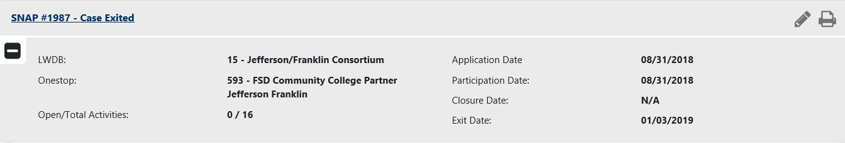
If a participant that your agency is actively working with has an Exit date on the SNAP application in MoJobs, send the DCN verification form to DSS.FSD.Agreements@dss.mo.gov with “loss of benefits” in the subject line. If the client is with you, enter “client at desk” in the subject line also. FSD staff will respond with SNAP eligibility information for the participant.
Active Food Stamps
- Forward the returned DCN form to SkillUp.Missouri@dss.mo.gov and request the SNAP application be unexited.
  - If the application has exited and there is another Partial or Incomplete application, staff will need to track any activities or services provided until the SNAP application has been unexited. These cases may take 30 days or more to correct.
  - Submit a change request to SkillUp.Missouri@dss.mo.gov with dates of service if they need to be backdated more than 15 days after the SNAP app has been unexited.

Not Active Food Stamps

- If the participant lost benefits and is in a long term training that has already been paid for, use case notes in MoJobs to document progress in the training, when the long term training is completed send a change request to SkillUP.Missouri@dss.mo.gov with the actual end date of training and the completion code (successful, unsuccessful, dropped out, etc.)
- If the participant lost benefits and has not regained benefits and they are not enrolled in a long term training, your agency cannot provide any additional services until the participant is eligible for Food Stamps again.
- If the participant lost benefits due to employment, staff can provide 90 days of job retention services such as TRE & WRE. You will need to keep these records at your agency and case note in MoJobs, you will not add any TRE or WRE services to the SNAP application at this time.

